**English 2C U9 - Health Issues**

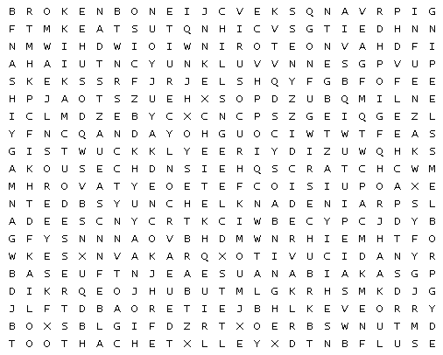

|  |  |  |  |  |  |
| --- | --- | --- | --- | --- | --- |
| ACHE |  | BACK ACHE |  | BROKEN BONE |  |
| BRUISE |  | CHILLS |  | COLD |  |
| COUGH |  | CUT |  | DIZZYNESS |  |
| FEVER |  | FLU |  | HEADACHE |  |
| INFUENZA |  | INSOMNIA |  | NAUSEA |  |
| PAIN |  | PROBLEMS SLEEPING |  | RUNNY NOSE |  |
| SCRATCH |  | SNAKE BITE |  | SORE EYES |  |
| SORE THROAT |  | SPRAINED ANKLE |  | STOMACHE ACHE |  |
| STRESSED OUT |  | SUNBURN |  | TOOTH ACHE |  |
| TWISTED KNEE |  | VIRUS |  | VOMIT |  |

Eng2C U9 HealthIssuesWordSearch AjarnGlen©

http://puzzlemaker.discoveryeducation.com/WordSearchSetupForm.asp